**Task-9**

**Computer Networks (Lab)**



**Submitted to** Asma Abubakar

**Submitted by** Talha

**Roll #:** F22-070

**Section:** SE-5B

**Submitted on** Dec 10, 2024

**DEPARTMENT OF SOFTWARE ENGINEERINGSUPERIOR UNIVERSITY, LAHORE**

Contents

Difference Between Sub-netting and Super-netting 3

Sub-netting 3

Example 3

Super-netting 3

Example 3

Direct Comparison 4

# Difference Between Sub-netting and Super-netting

## Subnetting:

Subnetting refers to the method or practice of partitioning a single class-bound network into sub-classes. It is primarily done to improve performance within an organization’s network by allowing better internal security and address management after breaking a larger dominant network into simpler and smaller segments.

Through the changing of the subnet mask of the host network, smaller subnets can be formed.

### Example

Imagine holding the network 167.158.0.0/16 with the address from 167.158.0.0 to 167.158.255.255 with the wish of decanting this particular network into 4. In this case you could do so by subnetting into four smaller ones with a subnet mask of 255.255.192.0 thus making it /18

**Original Network**

* 167.158.0.0/16

**New Subnets**

* 167.158.0.0/18 (addresses from 167.158.0.0 to 167.158.63.255)
* 167.158.64.0/18 (addresses from 167.158.64.0 to 167.158.127.255)
* 167.158.128.0/18 (addresses from 167.158.128.0 to 167.158.191.255)
* 167.158.192.0/18 (addresses from 167.158.192.0 to 167.158.255.255)

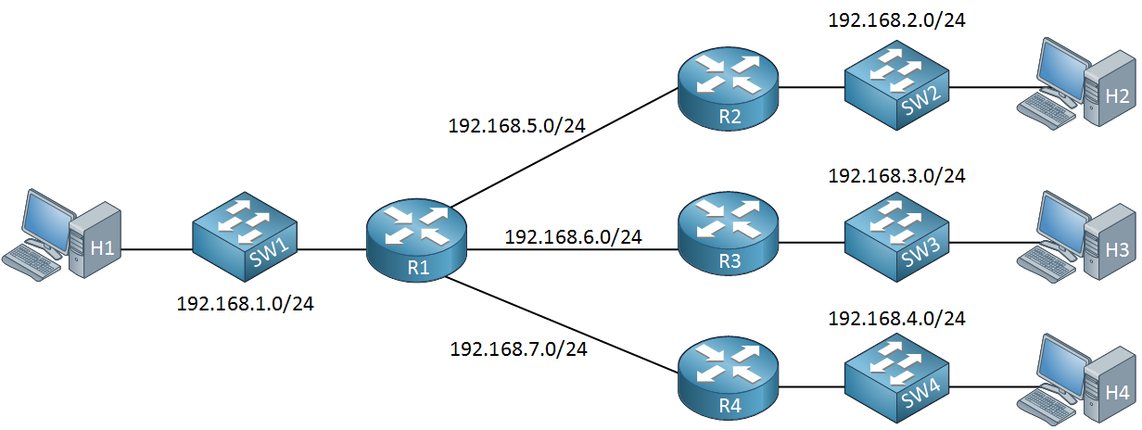

## Super-netting

Super-netting is a process of joining many sub-classes networks of one class to one dominant class, therefore super-netting goes against the principles of subnetting. Such practice is mostly required when an organization wants to pull together its networks, or when a range of IP addresses need to be simplified primarily to help in routing at the higher level of the internet routing table.

With super-netting, it is possible to use CIDR to join multiple networks and make them a single network, distinguished by one common prefix.

### Example

If you have four subnets, each with a network like 192.168.1.0/24, 192.168.2.0/24, 192.168.3.0/24, and 192.168.4.0/24, you could super-net these networks into one larger network with a /22 prefix, which includes all the addresses in these smaller subnets.

**Original Networks**

* 192.168.1.0/24
* 192.168.2.0/24
* 192.168.3.0/24
* 192.168.4.0/24

**Super-netted Networks**

* 192.168.0.0/22

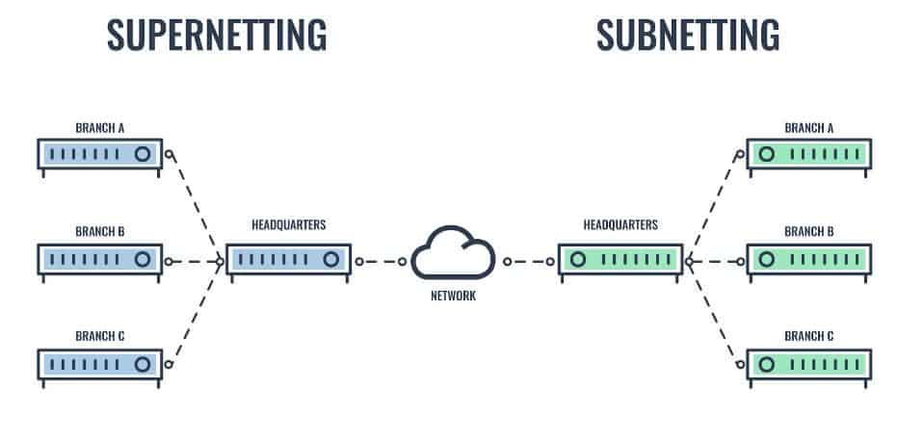

## Direct Comparison

|  |  |  |
| --- | --- | --- |
|  | **Sub-netting** | **Super-netting** |
| **Purpose** | Divides a large network into multiple smaller networks | Combines smaller networks into a larger network |
| **Network Size** | Results in smaller networks (more network bits are used) | Results in larger networks (less network bits are used) |
| **Usage** | Used for organizing local area networks | Used for aggregating addresses for routing efficiency |